

Zoe Haggett
zoe.haggett@student.curtin.edu.au

Logbook

RTOS Project Background
An operating system manages the allocation of system resources to the various tasks that need to be performed. Well known examples of an OS include Windows, Mac, Linux, and Android. These are all focused on providing the smoothest experience for the user. In an embedded system environment, we will typically use a real-time OS which is designed to meet strict deadlines to ensure that the system can respond quickly to its environment. We are currently making use of FreeRTOS because it is free to use and has package support built into the STM32CubeIDE.

RTOS Project Deliverables
- Explain what a queue, mutex and semaphore are in the context of an operating system.
  - Describe a suitable use case for each.
- Re-create the LED blink program from 5.3 but use two separate tasks to switch the LED on and off at different rates.
- Create a program that can safely transfer data between two tasks.
  - Some examples of data that could be transferred: Current iteration number, the number of blinks to do, the speed of blinks.
- Provide an Inter-Process Communication (IPC) Diagram or Task Synchronization Flowchart.
  - This should outline how the processes interact, share resources, and avoid race conditions.

Extra Project Deliverables
- Research how an RTOS could be used in a Flight Computer.
Research could include:
- Which tasks the system would be responsible for, e.g. polling subsystems, creating packets, sending packets, responding to commands.
- Which tasks require the highest priority.
- How the system would handle task failures.
WEEK 1: 17 – 23 August 2026
Research Phase
Total Hours Spent: 4
Running Total: 4

19/08/2026 Hours: 2

Introduction to PAST
- Attended first onboarding session and met other software recruits!
- Completed team-building exercises and ice breakers.
- Completed onboarding quiz.

20/08/2026 Hours: 1

Choose Project & Complete Preliminary Research
- Set up logbook.

- Begin basic research questions document – What are RTOSs? Examples? Benefits?
RTOS Project - Research Phase.docx
https://www.ibm.com/think/topics/real-time-operating-system

- Write out which research questions to answer by Week 2.

21/08/2026 Hours: 1

Explore FreeRTOS Beginner Guide and Set-Up
- Read through attached beginners guide - https://freertos.org/Documentation/01-FreeRTOS-quick-start/01-Beginners-guide/01-RTOS-fundamentals

- Download Microsoft Visual Studio, Git Bash, and clone FreeRTOS repository into Visual Studio.
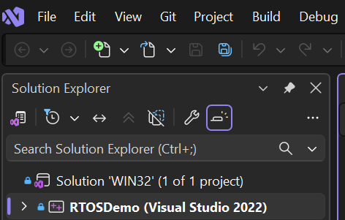

- Watch set-up video attached (given from project repository):
https://www.youtube.com/watch?v=OPrcpbKNSjU

WEEK 2: 24 – 30 August 2026
Research Phase
Total Hours Spent: 4
Running Total: 8
26/08/2026 Hours: 2

- Begin first deliverable.
Explain what a queue, mutex and semaphore are in the context of an operating system. Describe a suitable use case for each.
RTOS Project - Research Phase.docx
https://www.tpointtech.com/os-process-queues#google_vignette
https://medium.com/teamshiksha/a-primer-on-queuing-systems-in-computer-science-76743c1196de

28/08/2026 Hours: 2

- Complete first deliverable in ‘RTOS Project – Research Phase’ document.
Describe suitable use cases for each researched topic.

https://www.lenovo.com/us/en/glossary/what-is-mutex/?orgRef=https%253A%252F%252Fwww.google.com%252F&srsltid=AfmBOop-vUhRzGO61-JmUnY4rtg1SGpOXfri-q3G7hRQUDVuTFrDXfjk

https://www.geeksforgeeks.org/operating-systems/mutex-vs-semaphore/

https://www.geeksforgeeks.org/operating-systems/semaphores-in-process-synchronization/

WEEK 3: 31 – 6 September 2026
Implementation Phase
Total Hours Spent: 4
Running Total: 12
05/09/2026 Hours: 3

- Begin second deliverable.
Re-create the LED blink program from 5.3 but use two separate tasks to switch the LED on and off at different rates.

- Download ‘main.c’ and ‘main.blinky.c’ and run/observe basic demonstration on MSVC of how to use a queue on FreeRTOS to pass a value between two tasks, i.e. toggling an LED.

https://freertos.org/Documentation/01-FreeRTOS-quick-start/01-Beginners-guide/03-Build-your-first-project

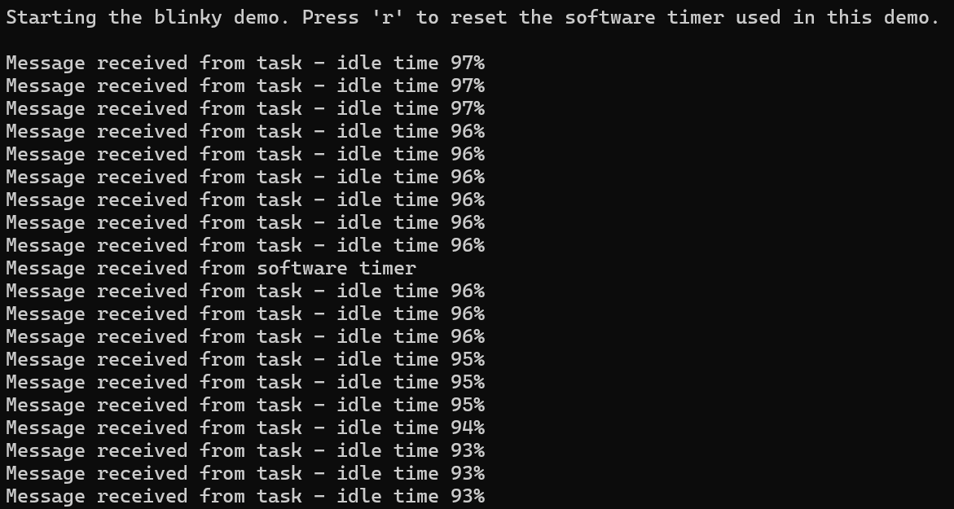

- Run 5.03 blink program demo from Software resources on GitHub. Install STM32CubeIDE and set-up, fix errors, follow instructions. I have noticed this program uses a while loop to both turn on the LED and turn it off in one task. In the deliverable, I must change this to make one task for ‘turning off’ and one task for ‘turning on.’

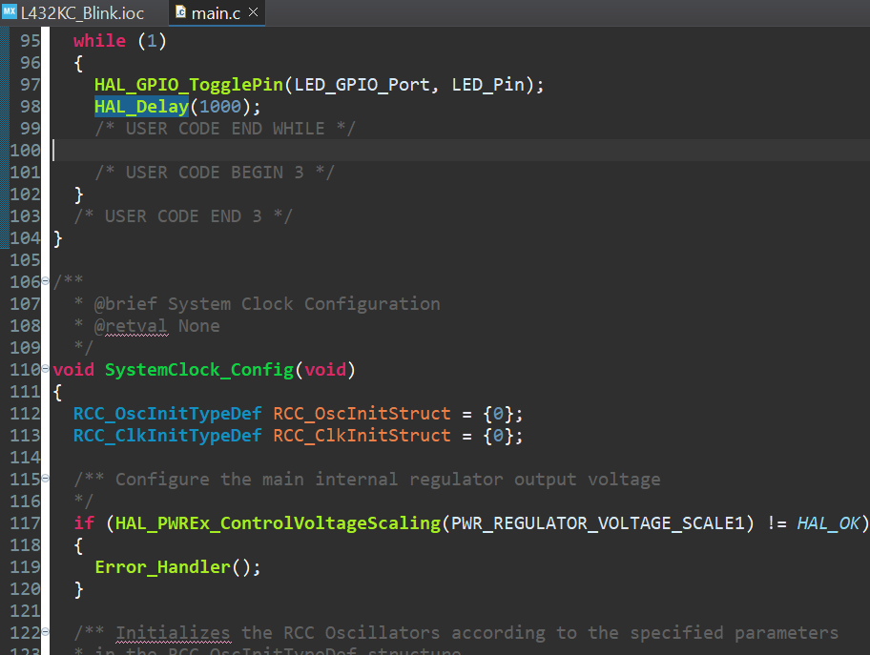

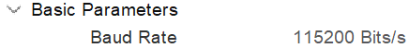

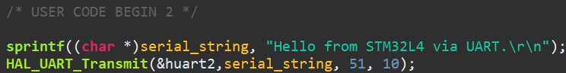

06/09/2026 Hours: 1

- Explore using STM32IDE, learn how it works, watch tutorials on two-task programs for blinking LEDs on YouTube.

https://www.youtube.com/watch?v=JIr7Xm_riRs
https://www.youtube.com/watch?v=OPrcpbKNSjU&t=16s
https://www.youtube.com/watch?v=hyZS2p1tW-g

WEEK 4: 7 – 13 September 2026
Implementation Phase
Total Hours Spent: 6
Running Total: 18
09/09/2026 Hours: 4

- Test STM32 microcontroller with blinking demo created on STM32CubeIDE.
It worked well and blinked without errors or problems, so now I can move forward to trying to replace the while loop with two separate tasks instead.
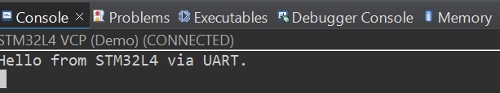
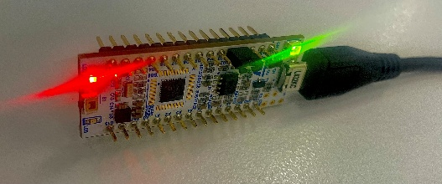
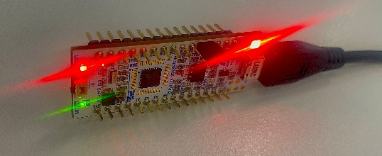

- Research terminology of STM32 microcontroller and STM32CubeIDE functions to know how to word re-created program for second deliverable.
RTOS Project - Understanding STM32CubeIDE Functions.docx

- Begin working on ‘ON’ and ‘OFF’ task for LED program.

Watched tutorial of using FreeRTOS in STM32CubeIDE to create separate tasks for the microcontroller: https://www.youtube.com/watch?v=9H87Qlimlhk

Gathered functions from: https://deepbluembedded.com/stm32-gpio-write-pin-digital-output-lab/

Add ON/OFF tasks to .ioc file.
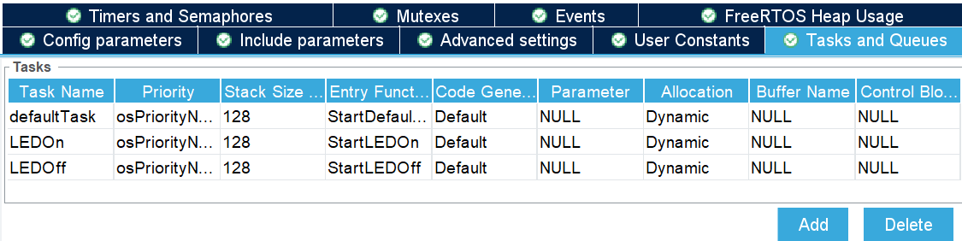

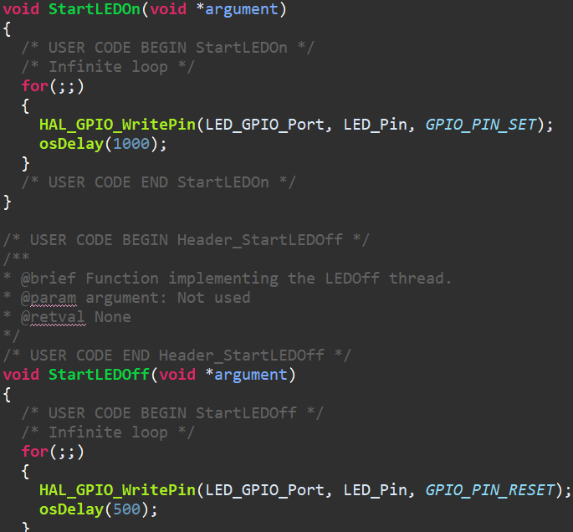
Add code to main.c file assigning a pin state to each task and assigning a different task delay to each.
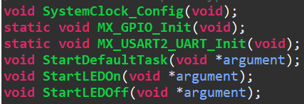
Initial code auto generated from .ioc file after adding new tasks:

- Finished code until I can test with STM32 microcontroller next week. Link repository to STM32CubeIDE. Add program to RTOS project repository.

12/09/2026 Hours: 2

- Begin third deliverable.
Create a program that can safely transfer data between two tasks.
  - Some examples of data that could be transferred: Current iteration number, the number of blinks to do, the speed of blinks.

- Look into YouTube videos on queues in STM32CubeIDE and how to use a queue for a task.
https://www.youtube.com/watch?v=TAY9shuSdlE&t=111s
https://www.youtube.com/watch?v=wMp5GQLobio&t=243s
https://www.youtube.com/watch?v=N1A1-Ioqkj8

WEEK 5: 14 – 20 September 2026
Implementation Phase
Total Hours Spent: 2.5
Running Total: 20.5
16/09/2026 Hours: 2.5

- Test two-task blinking demo, written in week 4. It didn’t work at first as my STM32CubeIDE was getting errors around connectivity, and the LED therefore was not blinking. After some debugging, and research into why my connectivity was being strange, I figured it was not a code issue and was an issue with my application, I could not get it fixed before the end of session, so debugged some things and will retry next meeting.

- Works when using ‘run’ instead of ‘debug’ – non-code error.
- Confirmed code for second deliverable works!

(Note: I had to begin 4 group assignments this week and could not meet the 4-hour time estimate – but will put more hours into week 6 as a result!)

WEEK 6: 21 – 27 September 2026
Implementation Phase
Total Hours Spent: 5
Running Total: 25.5
25/09/2026 Hours: 2

- Create tasks for sending data to the queue (SendTask), and for receiving data from queue (ReceiveTask).
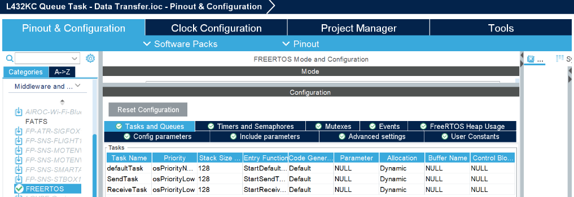

- Create queue (queue size of 10 messages, and item size of 4 bytes – amount for an integer).

- Change time source to a HAL time base source, as FreeRTOS uses a periodic tick for scheduling as well, and these can clash and cause errors. Allow FreeRTOS to use SysTick and change system time source to an alternative (in this case TIM6).

- Added a string, similar to the one in the 5.3 LED Blinking Demo from the GitHub, but to state the number of iterations received into the serial terminal on the application.
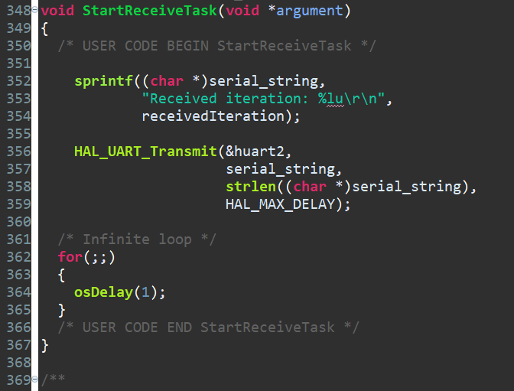

- Add #include <string.h> so that can add string-handling definitions in order to describe number of iterations on console when running the code.
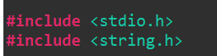

27/09/2026 Hours: 3

- Create code for the task sending data.
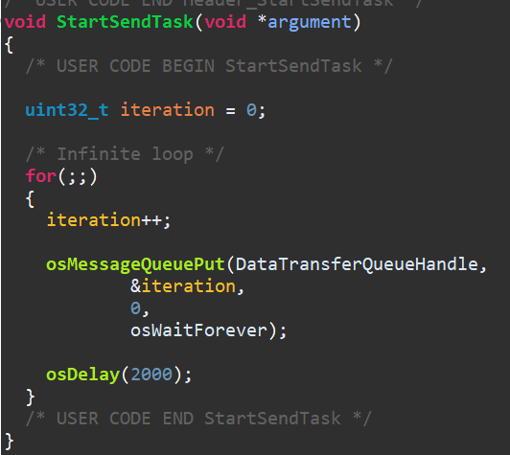
Simply, this code creates an integer number beginning at 0, increases the number in iterations, puts the number into the created queue, and then will wait 2 seconds before sending that number.

- Create code for the task receiving and displaying data.
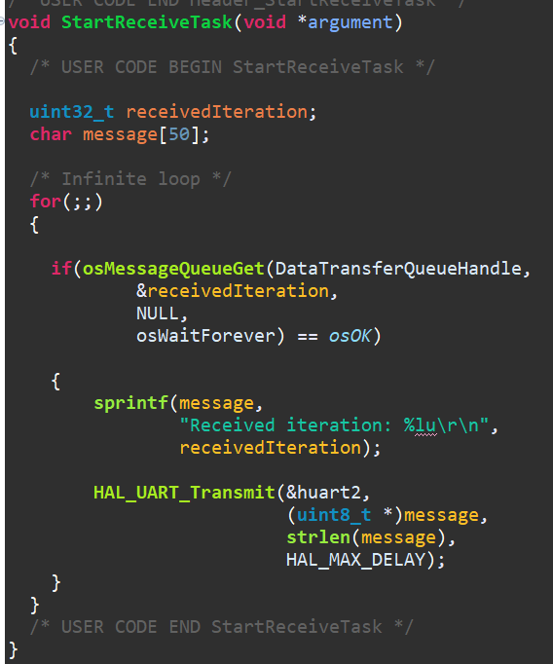
Simply, this code creates a variable to hold the iteration number (which can be displayed to maximum 50 characters), waits for a number to be sent, adds said number to the variable, turns this into a message, and then displays this message on the console.

- Once again, included the string of text from the 5.3 blinking demo to use as a check for how the code runs when tested.

Finished this file for this week, as I need to test before making any further changes.

- Decided to make another file for this deliverable where data sent will be number of blinks an LED must do and at what speed, and then once received this task will be displayed on the microcontroller.
So, re-did all set-up from the above file and added sender/receiver tasks and queue but for a different purpose. I will also not be adding 2 separate tasks for turning the LED on/off as I want it to be as simple as possible, so as not to lose the new purpose of this deliverable.

- Create combined structure for number of blinks desired and speed at which it blinks on and off.
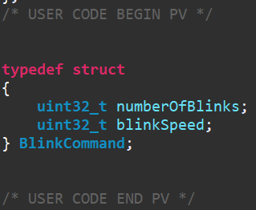
Creates one combined piece of information to send that includes the number of blinks required and at what speed to flash on/off.

- Create new SendTask.
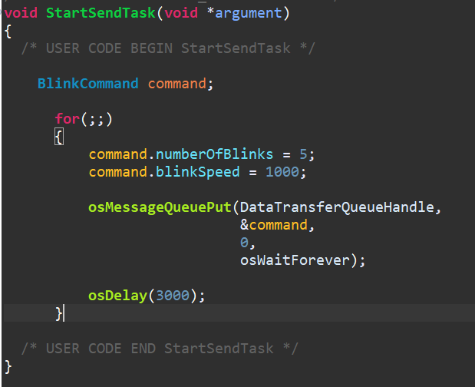
The new SendTask involved the package of information created, what numbers to hold within it, puts that package to the queue, and waits 3 seconds before sending it to the receiving task.

- Create new ReceiveTask. This new task is much longer as it also involves blinking the LED instead of simply printing information onto the console.
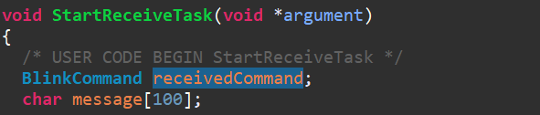
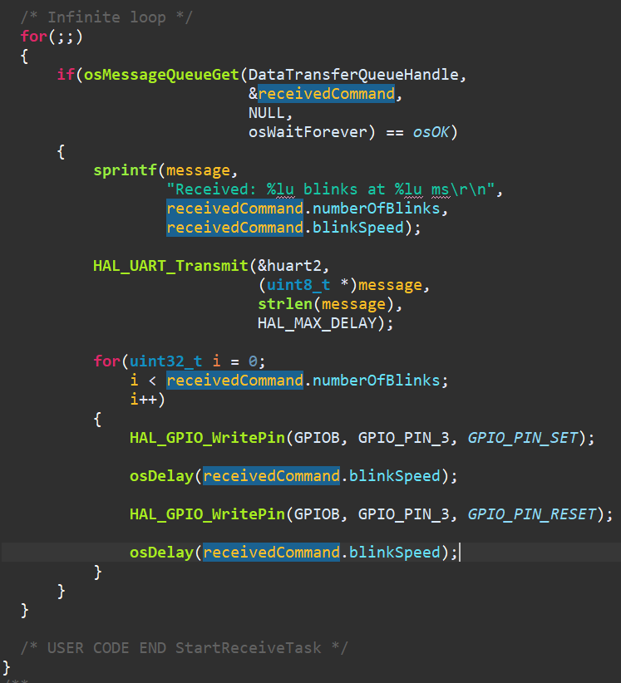

New ReceiveTask creates a variable to hold the values in the package sent, waits for values to arrive, translates the two values to a message string stating “Received: __ blinks at __ ms)”, prints this message to the console, then goes through a loop up to the values i= number of blinks where the LED pin is turned ON and then waits the speed amount of time before turning OFF (repeating until done).

- Upload both files to GitHub repository and wait until I can test!

WEEK 7: 5 – 11 October 2026
Total Hours Spent:
Running Total:
WEEK 8: 12 – 18 October 2026
Total Hours Spent:
Running Total:

